Seminar 8

**Question:**

Please propose 2-3 realization approaches according to the required functions assigned to each group. It is asked to:

* Take into account the practical components parameters and control scheme;
* Discuss the differences between the proposals that you provide;
* Select the optimal one among your proposals and state your reason;
* Simulation and analysis on operating principle.

Group 6**:** You are assigned to design a DC-DC Switching Mode Power Supply. The input voltage should be set as 12Vdc for each phase, and the output voltage and current should be set as 220Vdc/30A. You should also pay attention that the peak-to-peak value of the output voltage ripple should not be larger than 5% of nominal output voltage.

**Answer:**

The Topic needs us to use a switching power supply to design the circuits. Switching power supply can transform the AC source to DC source. By the requirement of the topic, we come up with 2 ways to achieve it.

For first way, the basic idea is a full-bridge inverter + full-wave rectifier structure. In this circuit, we use full bridge inverter to change DC to AC, through the transformer, we use full wave rectifier to change AC to DC. And the circuit is showed below. We can divide it into two parts. The left part is a full bridge invertor and the right part is a full wave rectifier. They are connected by a transformer.

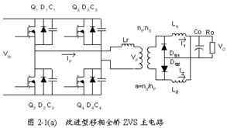

For the inverter, we use soft witches to constitute the it. S1 and S4 will be turned on and off synchronously. S2 and S3 will be turned on and off synchronously. The two group switches have 180°phase-shifting. So, the output voltage waveform (the voltage of the primary side of the transformer) will be positive when S1 and S4 on, and will be negative when S2 and S3 on. Then the input DC voltage becomes AC square waveform.

By the transforming of transformer, the energy can be transmitted from the invertor to the rectifier.

Then, by the rectification of two diode, we can get the DC source from the output of rectifier. By the buffering of inductance and capacitance, we can get a stable voltage in the resistance with a little ripple waves.

The advantage of the circuit is that we realize the **isolation** between input and output. What’s more, the circuit can work in a **high frequency**.

We use Simulink to simulate the circuit. All the elsements work in an ideal environment.

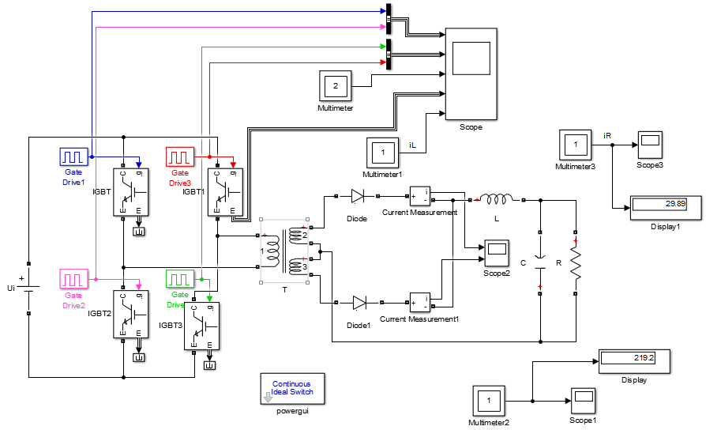

By adjust the duty circle, the ratio of transformer and the value of resistance, we can easily get the required voltage and current. The duty circle we set is 50% while the ratio is 6:220. And the value of resistance is 11Ω.

We observe the waveforms of voltage and current. We can find ripple waves as the effect of inductance and capacitance and the square wave in the output side of rectifier.

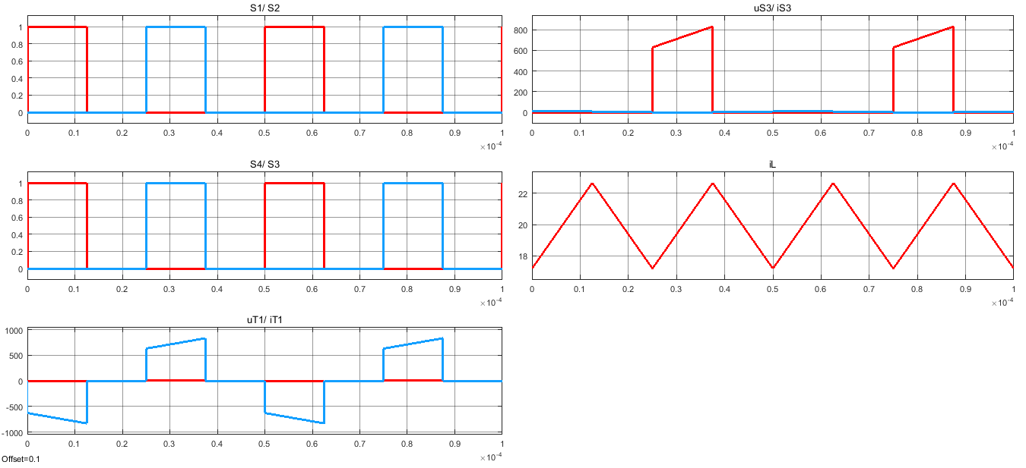

The trigger voltage of IGBT

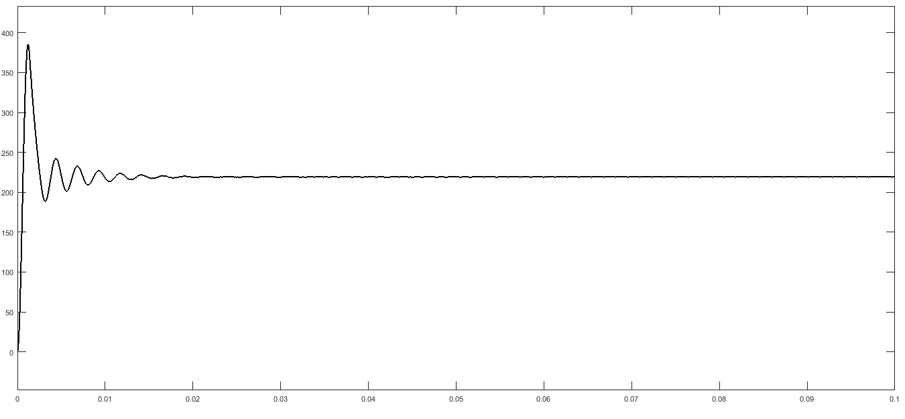

The output voltage

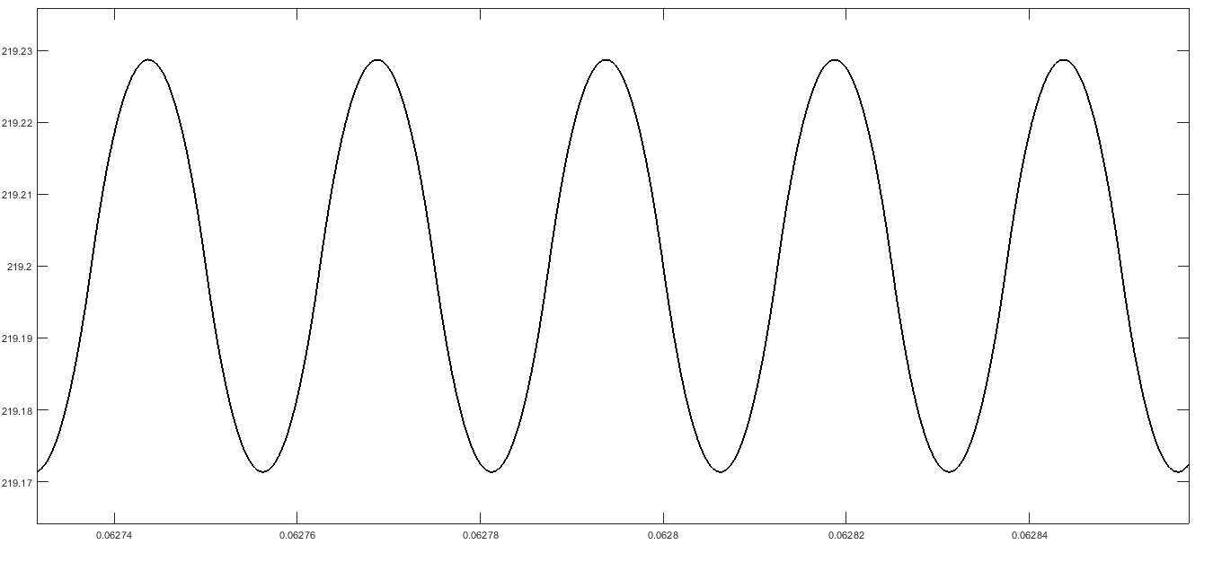

Amplified output volatge wave

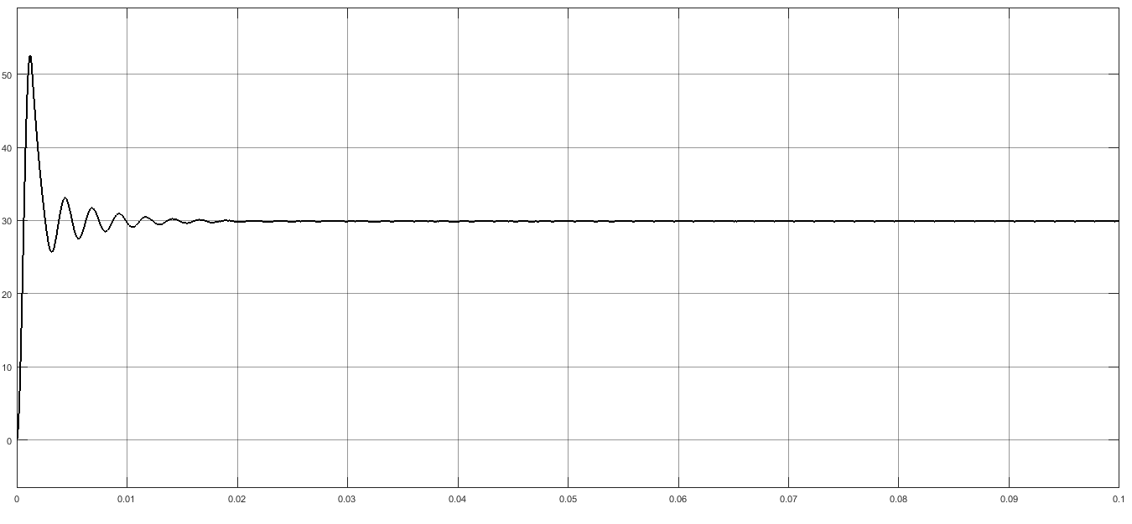

The output current (moving through resistance)

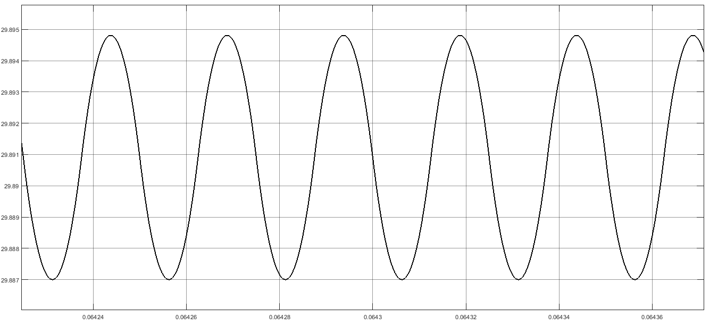

Amplified output current wave

The second way for us to achieve it is to add a feedback. By the feedback, we can reduce the time for the circuit to get stabilized and ripple wave.

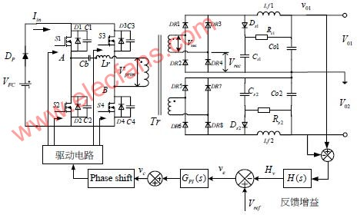

By simulation, we can get the figure of output voltage and current. It can be true that the waveforms of voltage and current are improved with the same parameters.

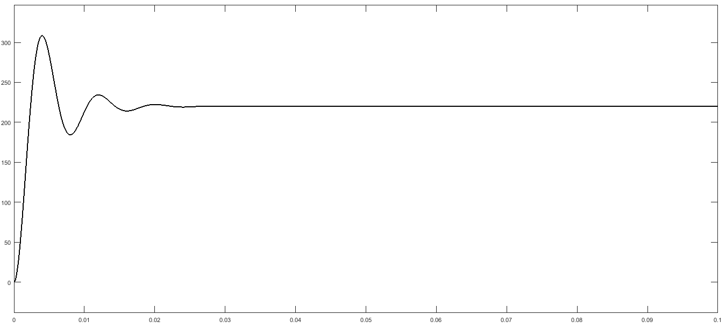

The output voltage

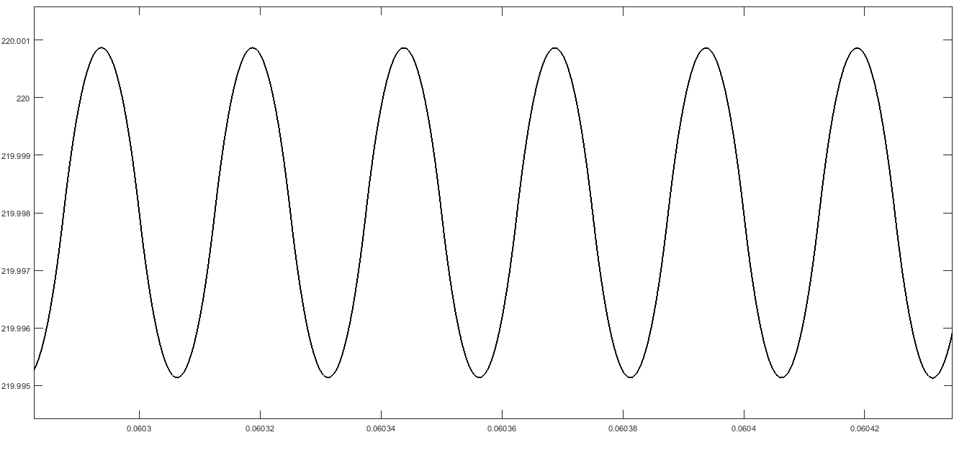

Amplified output volatge wave

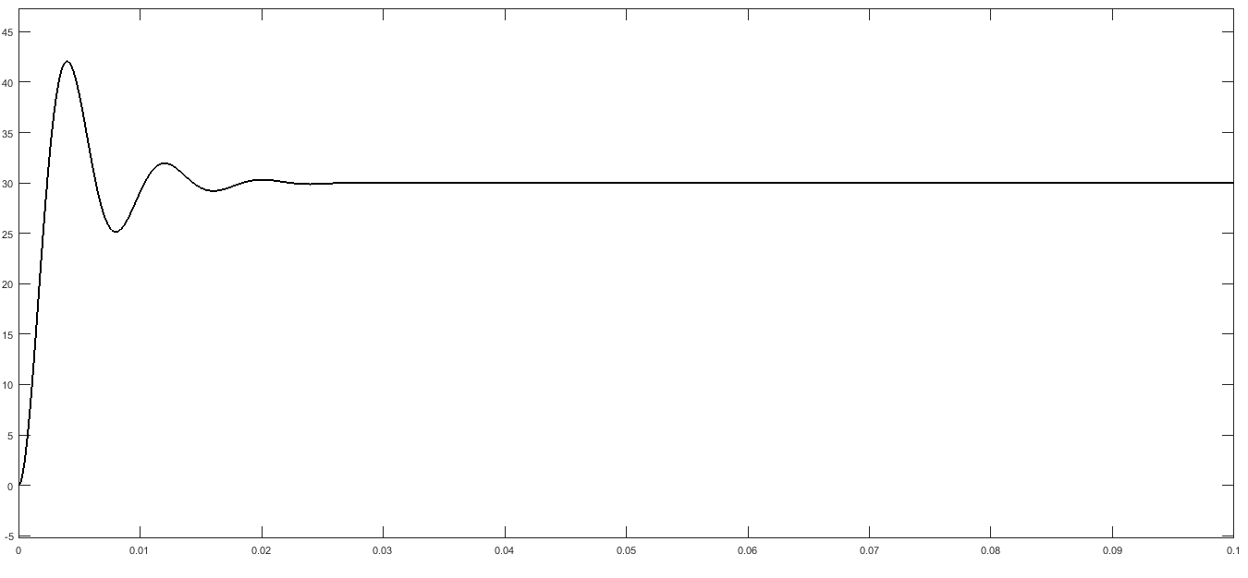

The output current (moving through resistance)

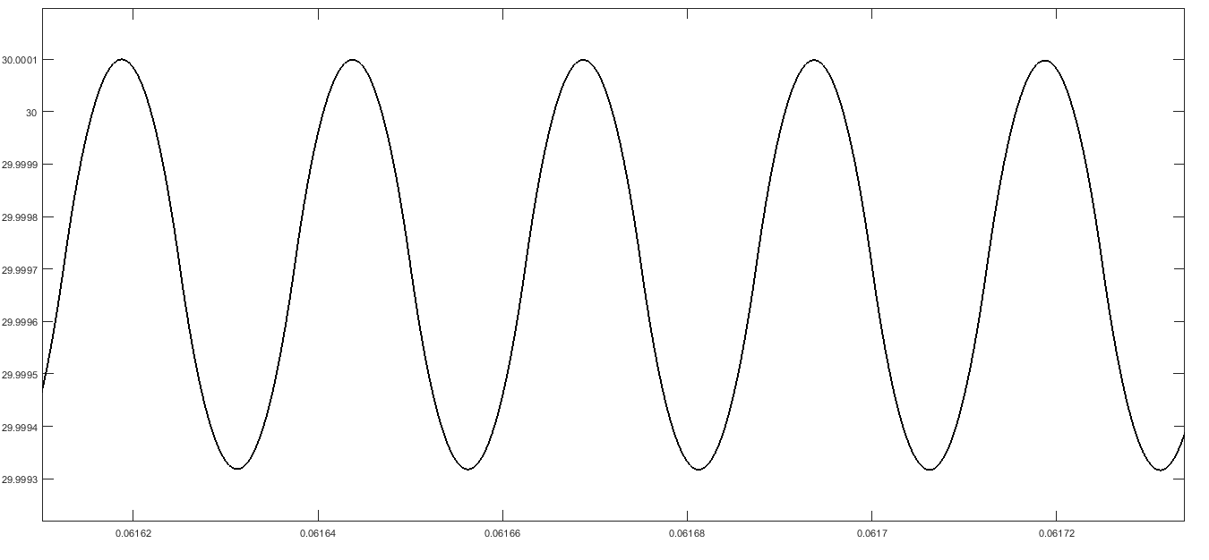

Amplified output current wave